# EXPT NO : 3 A python program to implement Logistic Model

**DATE: 6.9.2024**

# AIM:

To write a python program to implement a Logistic Model.

**PROCEDURE:**

Implementing Logistic method using the iris dataset involve the following steps:

# Step 1: Import Necessary Libraries

First, import the libraries that are essential for data manipulation, visualization, and model building.

# Step 1: Import Necessary Libraries

import numpy as np

import pandas as pd

import matplotlib.pyplot as plt

from sklearn.model_selection import train_test_split

from sklearn.linear_model import LogisticRegression

from sklearn.metrics import accuracy_score, confusion_matrix,

classification_report

# Step 2: Load the Iris Dataset The

iris dataset can be loaded.

# Step 2: Load the Dataset

|  |
| --- |
| # For this example, we'll use a built-in dataset from sklearn. You can replace it with your dataset. from sklearn.datasets import load_iris  # Load the iris dataset |
| data  = load_iris() |
| X = data.data  y = (data.target == 0).astype(int) # For binary classification (classifying |
| Iris-setosa) |

# Step 3: Data Preprocessing

Ensure the data is clean and ready for modeling. Since the Iris dataset is clean, minimal preprocessing is needed.

|  |
| --- |
| # Step 3: Prepare the Data  # Split the dataset into training and testing sets |
| X_train, X_test, y_train, y_test = train_test_split(X, y, test_size=0.2, |
| random_state=42) |

# Step 4 : Train a Model

**# Step 4: Create and Train the Model model = LogisticRegression()**

**model.fit(X_train, y_train)**

# OUTPUT :

**Step 5 : Make Predictions**

Use the model to make predictions based on the independent variable.

# Step 5: Make Predictions

y_pred = model.predict(X_test)

**Step 6 : Evaluate the Model** Evaluate the model performance.

# Step 6: Evaluate the Model accuracy = accuracy_score(y_test, y_pred) conf_matrix = confusion_matrix(y_test, y_pred) class_report = classification_report(y_test, y_pred)

# Print evaluation metrics print(f"Accuracy: {accuracy}") print("Confusion Matrix:") print(conf_matrix)

print("Classification Report:") print(class_report)

# OUTPUT :

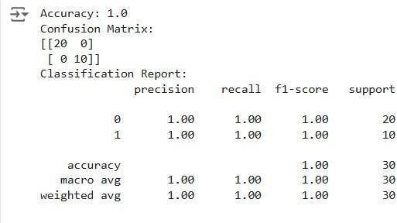

**Step 7 :Visualize the Results**

Plot the original data points and the fitted regression line.

# Step 7: Visualize Results (Optional)

|  |
| --- |
| x_values = np.linspace(-10, 10, 100) |
| sigmoid_values = 1 / (1 + np.exp(-x_values))  # Plot the sigmoid function |
| plt.figure(figsize=(10, 5))  plt.plot(x_values, sigmoid_values, label='Sigmoid Function', color='blue')  plt.title('Sigmoid Function') |

plt.xlabel('x')

plt.ylabel('σ(x)') plt.grid()

plt.axhline(0.5, color='red', linestyle='--') # Line at y=0.5

plt.axvline(0, color='gray', linestyle='--') # Line at x=0 plt.legend()

plt.show()

# OUTPUT :

**RESULT:**

This step-by-step process will help us to implement Logistic models using the Iris dataset and analyze their performance.